**Week 2 – Report**

Name – Jissy Jayaprakash

**Apply an Automated method for structure in GitHub and Understand what’s DevOps**

* I implemented a streamlined project initialization by using Cookie cutter tool using GitHub. Cookie cutter is a tool that helps to do the project easily with the project templates.
* I had given the screenshots of terminal commands that used to activate the cookie cutter.

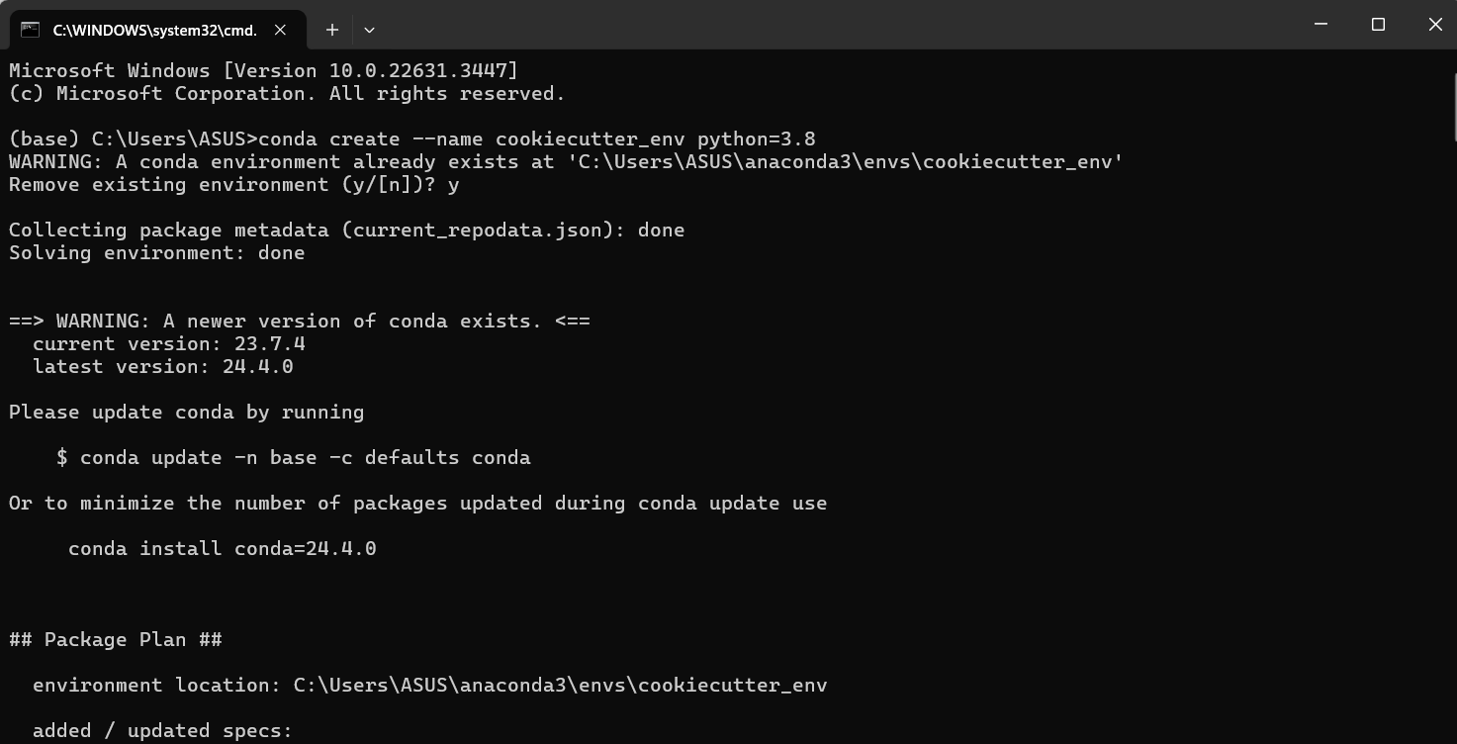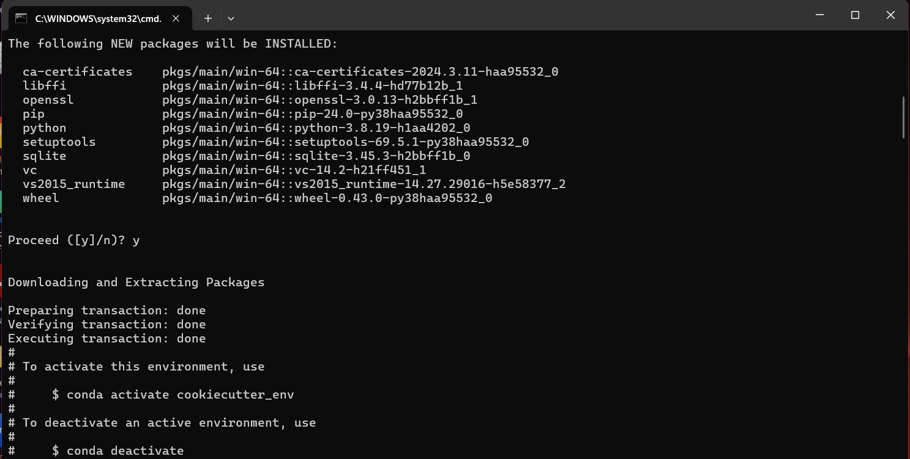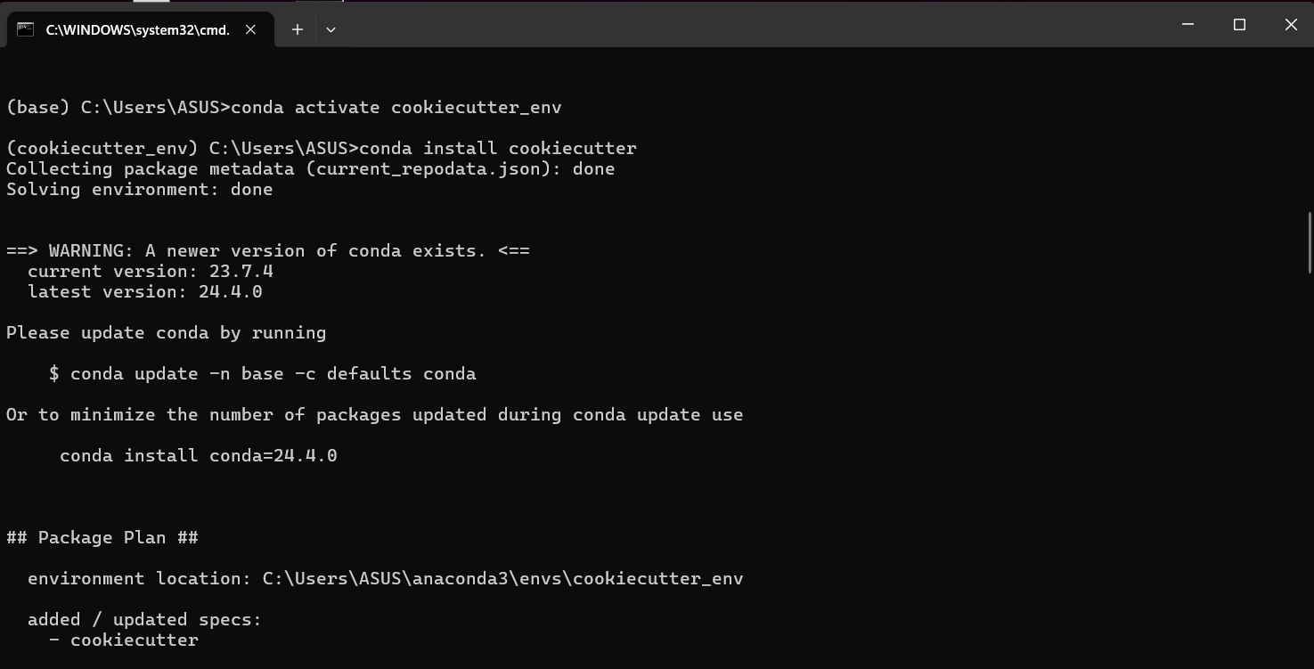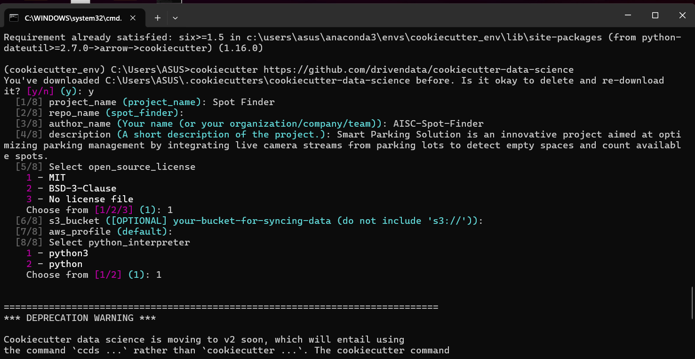

* After Completing the above process, Using the Github Desktop I Uploaded the Spot Finder folder in the Github. <https://github.com/amannain122/spot-finder>
* I uploaded with the comment – Initializing CookieCutter Data Science. Refer the below screenshot for the CookieCutter template.
* This is the cookiecutter data science template used in our project <https://github.com/drivendata/cookiecutter-data-science>

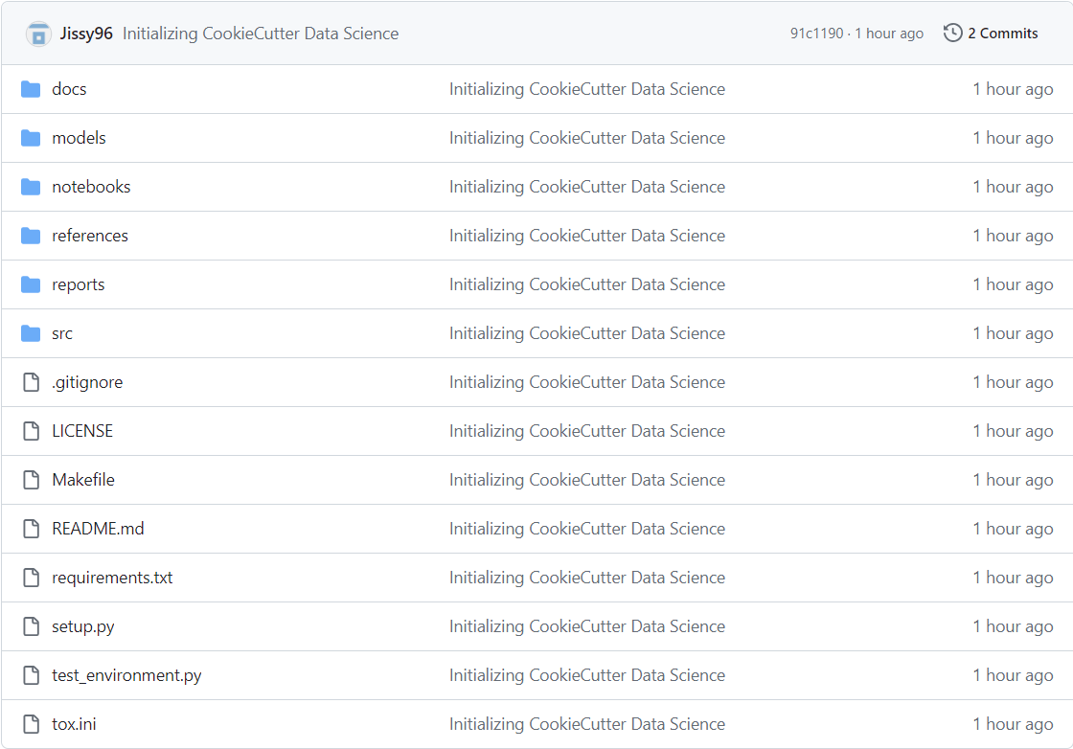

**Understanding DevOps**

* The software development comprises of mainly two important parts

Development Team

Operations Team

* The Development team plan, design and build the system.
* The Operations team do the implementation and check for the bugs and give the feedback to the development team. So, the Development team wait an idle for the feedback.
* This process will extend the timelines and delay the overall software development cycle
* There are chances that the development team started doing another new projects and operation team give feedback on old project. This process will take long time for a project to complete.
* Hence the DevOps came.
* Development Team and Operation Team working together to improve efficiency through the continuous process.
* The DevOps approach make faster development change by delivering quickly and deployment are more consistent.
* Development Team put down plan that the application objectives that are to be delivered to the customer. Then works on the code and store in the repository using tool like Git. Then the code is been executed.
* After the code is successfully build it’s been tested for bugs or errors. The most popular tool for testing is Selenium. Once the code is done it will send to the operation team for deployment.
* Now it will deploy to the working environment, that is done by operation team. Product is continuously monitored.
* The feedback received after this phase is send back to the Planning Phase.
* This is overall DevOps Lifecycle and the continuous Integration will happen.

In our Project, now I am researching about the tools that can be used for continuous integration, deployment, Monitoring and Testing.

